**Ex No: 9 Date:17/09/2024**

**Roll No:231901015**

**ANALYZE DIFFERENT TYPES OF SERVERS USING WEBALIZER**

**AIM:**

To analyze the different types of web logs using Webalizer tool.

**PROCEDURE**:

Step 1: Download Apache web server using- dnf install httpd

Step 2: Configure SELINUX to permissive mode

(open /etc/sysconfig/selinux Put SELINUX=permissive)

Step 3: Start Apache web server using- systemctl start httpd.service

Step 4: Create a directory for webalizer using - mkdir /var/www/html/webalizer

Step 5: Install webalizer using - dnf install webalizer

Step 6: Copy files from /var/www/usage to /var/www/html

Step 7: Open /etc/webalizer.conf file and add the following- LogFile /var/log/httpd/access_log

LogType clf

Hostname localhost

Output Dir /var/www/html/webalizer

Step 8: Save it and then run webalizer

Step 9: Open in web browser http://localhost/webalizer

#Instructions to install, configure and run Webalizer on Fedora

#Enter the root password after typing su

**Step-1:** Download Apache web server using- dnf install httpd d**nf install httpd**

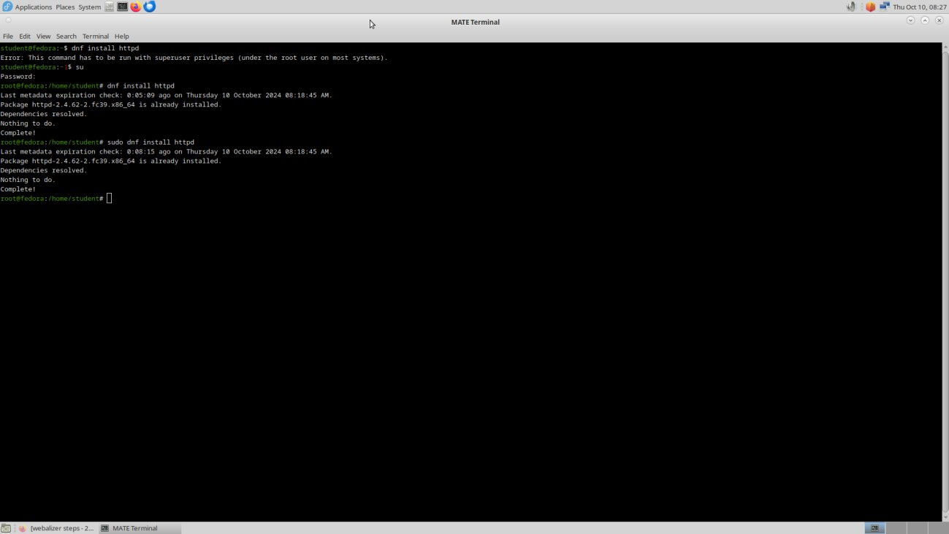

**Step-2:**Configure SELINUX to permissive mode

(open /etc/sysconfig/selinux Put SELINUX=permissive) **vi /etc/sysconfig/selinux**

Put SELINUX=permissive instead of enforcing

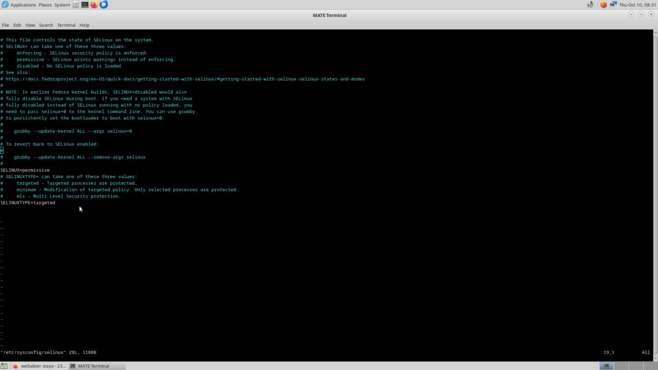

**Step 3:** Start Apache web server using- systemctl start httpd.service systemctl enable httpd.service systemctl start httpd.service

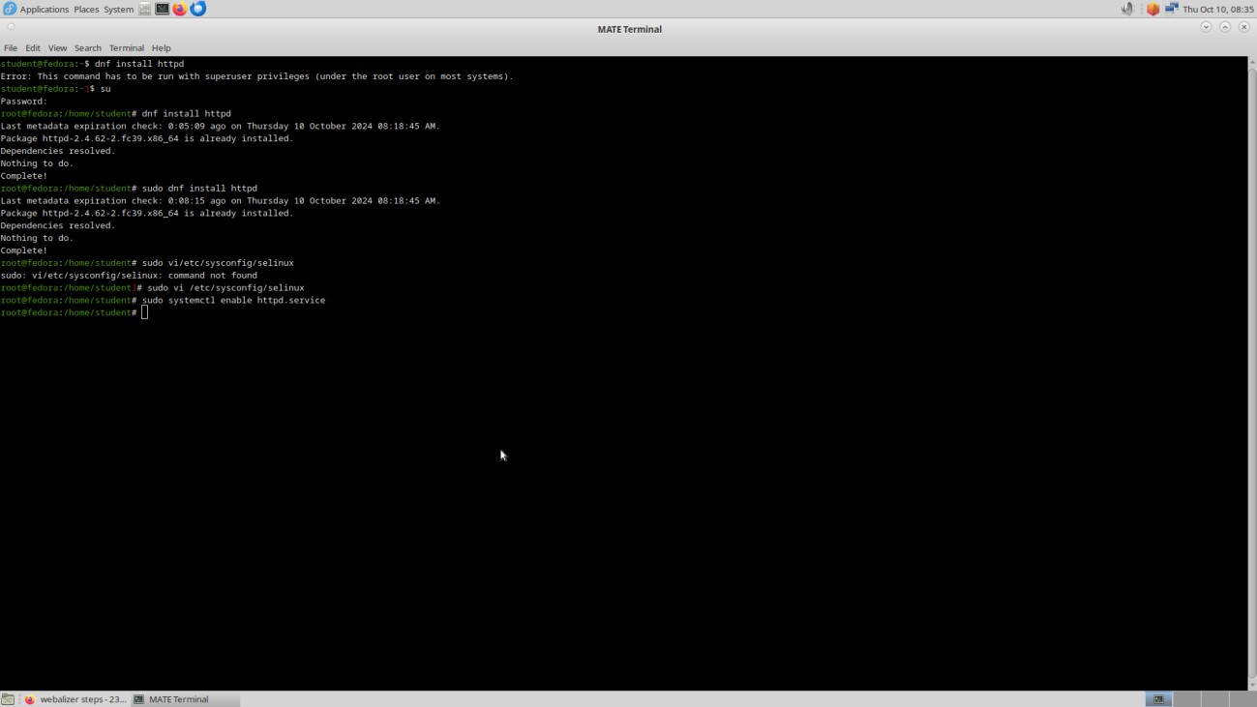

**Step 4:** Create a directory for webalizer using - mkdir /var/www/html/webalizer

mkdir /var/www/html/webalizer

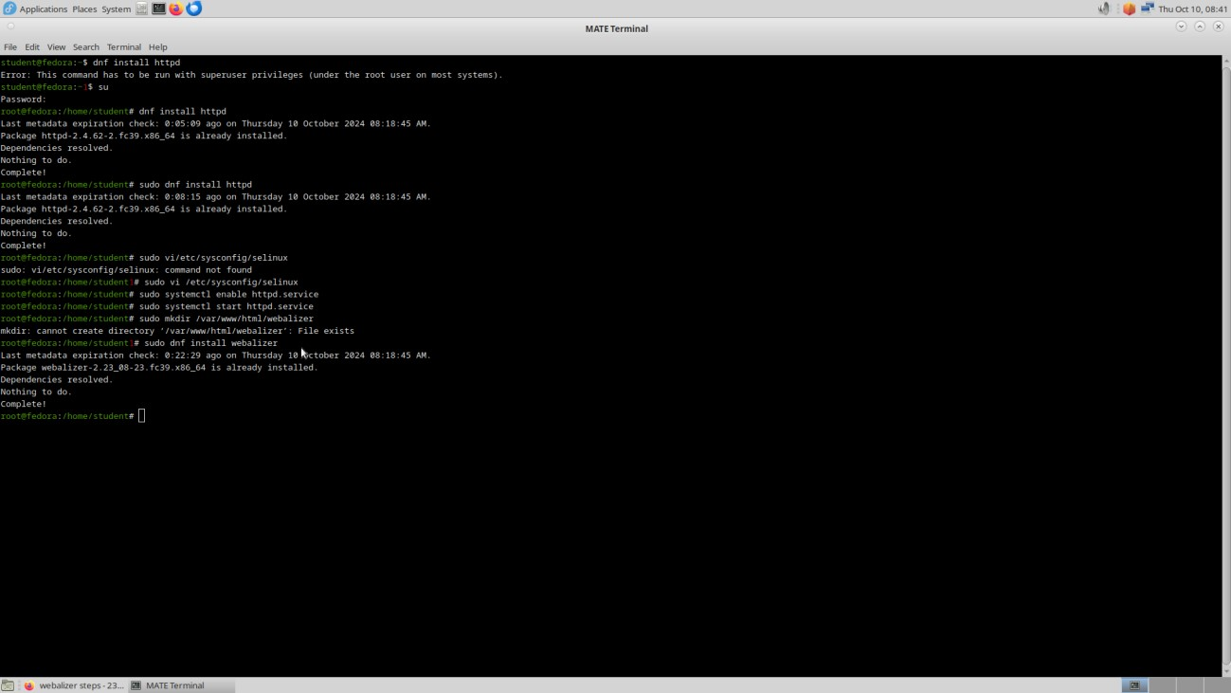

**Step 5:** Install webalizer using - dnf install webalizer

dnf install webalizer

**Step 6**: Copy files from /var/www/usage to /var/www/html

cp -r /var/www/usage /var/www/html

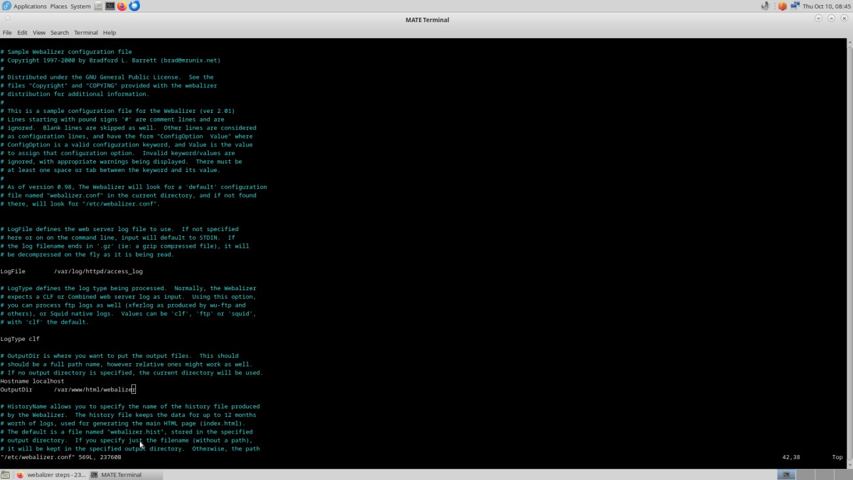

**Step 7:** Open /etc/webalizer.conf file and add the following-

vi /etc/webalizer.conf

#add the following lines

LogFile /var/log/httpd/access_log #This is enabled in newer versions of fedora LogType clf

Hostname localhost #For this one you can remove comment denoted by '#'

OutputDir /var/www/html/webalizer

**Step 8:** Save it and then run webalizer save it and then run

Webalizer

**Step** **9**: Open in web browser http://localhost/webalizer

Open in browser http://localhost/webalizer

Click Oct.2023 link to get the report for this month

Before running webalizer, restart httpd server by typing- systemctl restart httpd.service

**OUTPUT:**

**Monthly statistics**

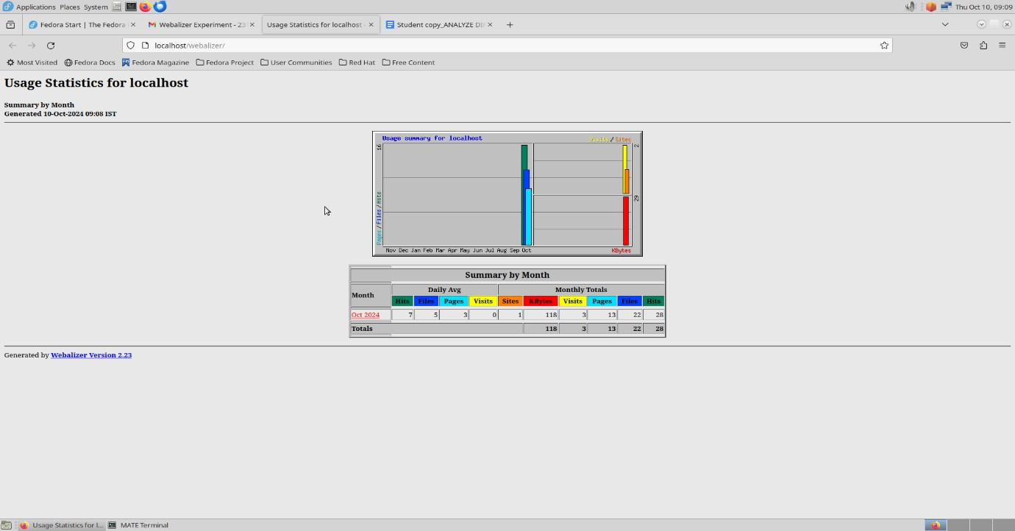

**Hosts**

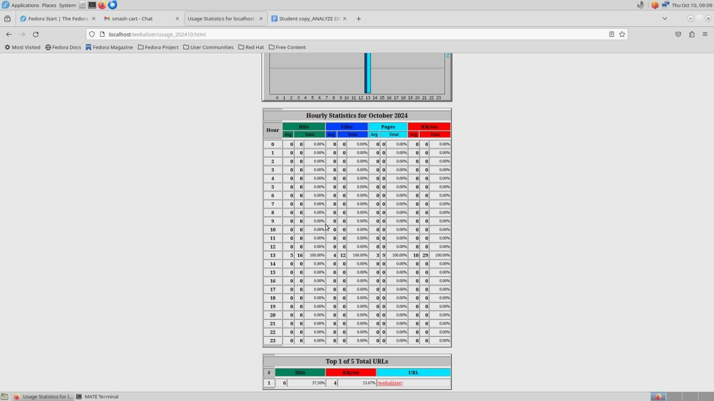

**Result:**

Thus,the experiment of Analyze of different types of server using Webalizer was done.